Batch: Roll No.:

Experiment / assignment / tutorial No._______

Grade: AA / AB / BB / BC / CC / CD /DD

Signature of the Staff In-charge with date

Experiment No.: 1

TITLE: Study of Network topology and Connecting devices (Hub,router,Gateway,Switch etc)

_____________________________________________________________________
AIM: To study different Network topologies and connecting devices used in day to day networks.
_____________________________________________________________________
Expected Outcome of Experiment:
CO:

__________________________________________________________________
Books/ Journals/ Websites referred:
- A. S. Tanenbaum, “Computer Networks”, Pearson Education, Fourth Edition
- B. A. Forouzan, “Data Communications and Networking”, TMH, Fourth Edition

____________________________________________________________________
Pre Lab/ Prior Concepts : Basics of LAN and Connecting devices
__________________________________________________________________
New Concepts to be learned: Layer wise connecting devices
___________________________________________________________________
Stepwise-Procedure:
Study of LAN
- Define various basic attributes used in designing of a network.

- Define LAN topology

3. Theoretical design of LAN using various topologies.

Study of Connecting Devices

Hub

A hub works in the physical layer of the OSI model. It is basically a non-intelligent device, and has no decision making capability. What a Hub basically does is take the input data from one of the ports and broadcast the information to all the other ports connected to the network.

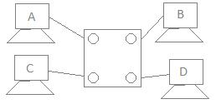
Fig 1: 4 port network

To demonstrate its working, consider a 4 port network as shown in Fig 1. There are 4 computers connected to the 4 ports. Suppose, if Computer A wants to send some data to Computer B using a Hub, then, Computer A broadcasts the data on the network, and Computer B, being connected to the network, has access to the data. But, in this case all the other ports connected to the network has access to the data that is being transmitted by Computer A. This happens because, the Hub works in the Physical Layer and hence it does not know about the MAC addresses of the ports connected to the network. So, there is a lack of security in the Hub.

Repeater

A repeater is a device similar to the Hub, but has additional features. It also works in the Physical layer. The repeaters are used in places where amplification of input signal is necessary. But, the kind of amplification done by the repeater is different from the regular amplification by amplifiers. The regular amplifies everything fed into it. That means, if the input signal has noise induced into it, both the desired signal and noise signal are together amplified. But, in the case of a repeater, it regenerates the input signal, and amplifies only the desirable signal. Hence, the noise component of the signal is eliminated.

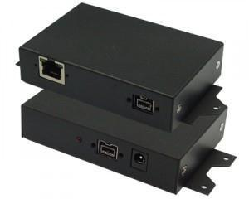
Fig 2: Repeater

The repeaters are necessary since, during the transmission of the signals over long distances, the signal has attenuation, delay distortions and noise, which lead in loss of data. Hence, in order to prevent this, the regenerative repeaters are used. Hence, the repeater regenerates the faded signal. In addition, it has all the features of a Hub. One common problem between the repeaters and the Hubs are that only one transmission can take place on the network at a particular time. If multiple devices transmit data simultaneously, there will be data collision.

Switch
A switch is an intelligent device that works in the data link layer. The term intelligent refers to the decision making capacity of the Switch. Since it works in the Data link layer, it has knowledge of the MAC addresses of the ports in the network.
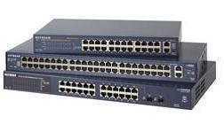
Fig 3: Switch
Hence, in the Fig 1, if data has to be sent from Computer A to Computer B, then, the data is transferred to the Computer C only, and not to any other computers connected on the network. Hence, it establishes a link between the sender and the receiver based on the MAC addresses. This also means that when data is being sent from A to B, Computer C can establish a link with Computer D and communication can take place between them. So, simultaneous data transfer is possible in a switch. Also, Hub divides bandwidth, but a Switch does not.
It is also to be noted that a switch is a secure device, because it sends information only to the desired destinations, and also certain security features such as firewalls can be implemented in the Switches.
Bridge
A bridge is also a device which works in the Data Link Layer, but is more primitive when compared to a switch. Initial bridges were used to connect only 2 LAN’s, but the most recent ones perform similar operation as the switches. It also works on the principle of transfer of information using the MAC addresses of the ports.
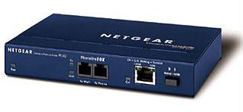
Fig 4: Bridge

It can be noted is that the normal ADSL modem can be connected via bridging also. The only difference is that, when bridging is used, each time the device has to be connected to the internet, it has to dial to the internet and establish a connection. Also, a bridge alone cannot be used to connect to the internet, because, the bridge works in the Data Link Layer, and has no knowledge of the IP Addresses, which are used in the Internet.

Router
Any computer can be connected to the internet via MODEM, which performs the MODulation and the DEModulation operations. But, when there are more than one computer at home or in an organization, and you have a single internet connection, you need a Router. Router is a device which is used when multiple devices need to connect to the Internet using the same IP.
Any Internet Service Provider (ISP) provides a single IP, and especially for personal use, the IP address is assigned dynamically. This is done because, suppose, an ISP has 1000 IP addresses, it does not mean that it has 1000 customers. An ISP assumes that not all devices will be connected to the internet at the same time. Hence, when a user wants to access the internet, any IP address from the pool of IP addresses from the ISP will be assigned to connect the user to the internet.
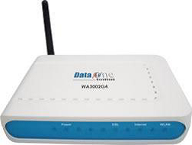
Fig 5: Router

Hence, the router does the job of connecting multiple devices in a LAN to the internet using the same IP address. Since the router works in the Network Layer, it does forwarding on the basis of IP addresses.

The WiFi routers that are commonly used now are the IEEE 802.11 b/g standard router, which is explained below.
Gateway
The Gateway devices work in the Transport layer and above, where the different network technologies are implemented. A gateway is necessary when there are different technologies implemented by the different LAN’s which are to be connected together.
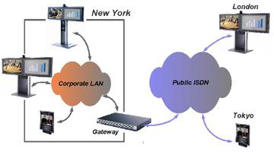
Fig 6: Gateway function
The Fig 6 shows the working of a gateway. Consider 2 networks, say in New York, and a network in London. If data has to be sent from one place to another, we need to ensure that the network technologies that are being used by both the networks are the same. If not, we need to use a Gateway.
In the more common example, we use a telephone network and internet networks, which works on different technologies. The telephone network follows the ISDN, and the Internet follows the IP. Here, 2 different technologies are being used. In this case, the router fails to work, since the router cannot understand the functionalities of both the networks. Hence, we require a Gateway, which acts as a translator in communicating between the 2 networks.
Connecting Cables
While connecting different networks, we come across different connecting cables, which are as follows:
RJ45/ RJ 11 Connectors: The RJ45 (Registered Jack 45) cable or the Cat 5 cable, is used to connect the two different LAN’s together. This is normally confused with the RJ11 cable, which is used in the interconnections in the telephone network.

Twisted pair cable
In balanced pair operation, the two wires carry equal and opposite signals and the destination detects the difference between the two. This is known as differential mode transmission. Noise sources introduce signals into the wires by coupling of electric or magnetic fields and tend to couple to both wires equally. The noise thus produces a common-mode signal which is canceled at the receiver when the difference signal is taken.
This method starts to fail when the noise source is close to the signal wires; the closer wire will couple with the noise more strongly and the common-mode rejection of the receiver will fail to eliminate it. This problem is especially apparent in telecommunication cables where pairs in the same cable lie next to each other for many miles. One pair can induce crosstalk in another and it is additive along the length of the cable. Twisting the pairs counters this effect as on each half twist the wire nearest to the noise-source is exchanged.
Providing the interfering source remains uniform, or nearly so, over the distance of a single twist, the induced noise will remain common-mode. Differential signaling also reduces electromagnetic radiation from the cable, along with the associated attenuation allowing for greater distance between exchanges.
The twist rate (also called pitch of the twist, usually defined in twists per meter) makes up part of the specification for a given type of cable. Where nearby pairs have equal twist rates, the same conductors of the different pairs may repeatedly lie next to each other, partially undoing the benefits of differential mode. For this reason it is commonly specified that, at least for cables containing small numbers of pairs, the twist rates must differ.[
UTP cables are found in many Ethernet networks and telephone systems. For indoor telephone applications, UTP is often grouped into sets of 25 pairs according to a standard 25-pair color code originally developed by AT&T Corporation. A typical subset of these colors (white/blue, blue/white, white/orange, orange/white) shows up in most UTP cables. The cables are typically made with copper wires measured at 22 or 24 American Wire Gauge (AWG),[3] with the colored insulation typically made from an insulator such as polyurethane and the total package covered in a polyurethane jacket.
For urban outdoor telephone cables containing hundreds or thousands of pairs, the cable is divided into smaller but identical bundles. Each bundle consists of twisted pairs that have different twist rates. The bundles are in turn twisted together to make up the cable. Pairs having the same twist rate within the cable can still experience some degree of crosstalk. Wire pairs are selected carefully to minimize crosstalk within a large cable.
Unshielded twisted pair cable with different twist rates
UTP cable is also the most common cable used in computer networking. Modern Ethernet, the most common data networking standard, can use UTP cables. Twisted pair cabling is often used in data networks for short and medium length connections because of its relatively lower costs compared to optical fiber and coaxial cable.
UTP is also finding increasing use in video applications, primarily in security cameras. Many cameras include a UTP output with screw terminals; UTP cable bandwidth has improved to match the baseband of television signals. As UTP is a balanced transmission line, a balun is needed to connect to unbalanced equipment, for example any using BNC connectors and designed for coaxial cable.
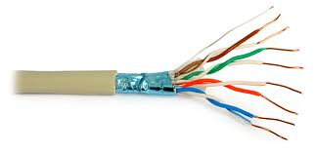
Fig 7.Twisted Pair Cable

Coaxial cable
Coaxial cable is the kind of copper cable used by cable TV companies between the community antenna and user homes and businesses. Coaxial cable is sometimes used by telephone companies from their central office to the telephone poles near users. It is also widely installed for use in business and corporation Ethernet and other types of local area network.
Coaxial cable is called "coaxial" because it includes one physicalchannel that carries the signal surrounded (after a layer of insulation) by another concentric physical channel, both running along the same axis. The outer channel serves as a ground. Many of these cables or pairs of coaxial tubes can be placed in a single outer sheathing and, with repeaters, can carry information for a great distance.
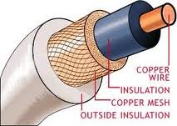
Fig 8.Coaxial Cable

Optical Fiber
Fiber-optic communication is a method of transmitting information from one place to another by sending pulses of light through an optical fiber. The light forms an electromagnetic carrier wave that is modulated to carry information. First developed in the 1970s, fiber-optic communication systems have revolutionized the telecommunications industry and have played a major role in the advent of the Information Age. Because of its advantages over electrical transmission, optical fibers have largely replaced copper wire communications in core networks in the developed world.
The process of communicating using fiber-optics involves the following basic steps: Creating the optical signal involving the use of a transmitter, relaying the signal along the fiber, ensuring that the signal does not become too distorted or weak, receiving the optical signal, and converting it into an electrical signal.
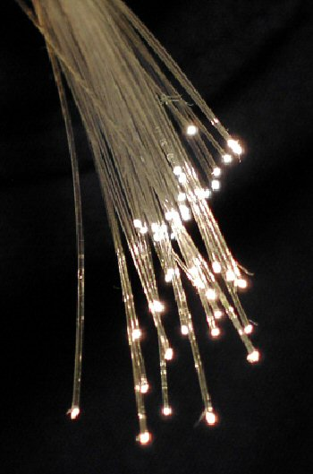
Fig 9.Fiber Optics Cable

Summary
The features of the connecting devices can be explained in brief as follows:
- Hub- Broadcasts data from one port to all other ports in the network.
- Repeater- Regenerates the input data which is subjected to attenuation.
- Switch- Intelligent device which sends data to particular port.
- Bridge-Same function as switch but much more primitive and has lesser ports.
- Router-Connects all computers from a LAN to internet using same IP.
- IEEE 802.11- WiFi standard- 802.11 b has speed of 11 Mbps, 802.11 g has a speed of 54 Mbps and 802.11 N uses multiple wireless signals and antennas and has speeds of over 100Mbps.
- Gateway-Needed when 2 different network technologies are being used. Acts as translator.

CONCLUSION:

Post Lab Questions

- Compare Hub, switch, bridge, and gateway and specify the use in different cases.

- Which of the following device is used to connect two systems, especially if the systems use different protocols?
A.hub
B.bridge
C.gateway
D.repeater
E.None of the above

- Frames from one LAN can be transmitted to another LAN via the device
A. Router
B. Bridge
C. Repeater
D. Modem

Batch: B1 Roll No.: 1711072

Experiment / assignment / tutorial No. 2

Grade: AA / AB / BB / BC / CC / CD /DD

Signature of the Staff In-charge with date

Experiment No.: 2

TITLE: Implementation of 11 bit Hamming Code for Computer Networks
_____________________________________________________________________
AIM: To implement Layer 2 Error Control schemes: Hamming Codes.
_____________________________________________________________________
Expected Outcome of Experiment:
CO: Describe Data Link Layer, MAC layer technologies &amp; protocols and implement the functionalities like error control, flow control.
__________________________________________________________________
Books/ Journals/ Websites referred:
- A. S. Tanenbaum, “Computer Networks”, Pearson Education, Fourth Edition
- B. A. Forouzan, “Data Communications and Networking”, TMH, Fourth Edition

____________________________________________________________________
Pre Lab/ Prior Concepts:
Data Link Layer, Error Correction/Detection, Types of Errors
___________________________________________________________________
New Concepts to be learned: Hamming Code.
___________________________________________________________________

Stepwise-Procedure:
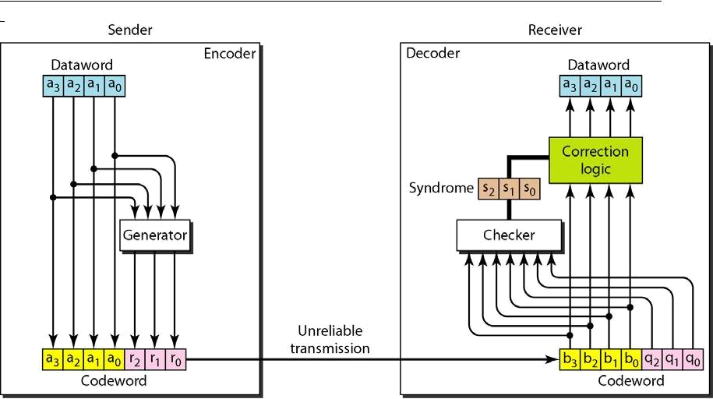
Consider data stream of 7 bytes. Number it from 1 from left hand side of the data stream.
Add parity bits like P_{0 ,} P_{1,} |  |  |  | and P2 etc. into the positions 2’s power like at 1,2,4,8.
1 | 0 | 1 P₄ 1 1 0 P₃ 1 P₂ P₁
D11 D10 |  | D9 | D7 D6 | D5 | D3

P₁ ₌ D3 EXOR D5 EXOR D7 EXOR D9 EXOR D11 = 1

P₂ ₌ D3 EXOR D6 EXOR D7 EXOR D10 EXOR D11= 1

P₃ ₌ D5 EXOR D6 EXOR D7 = 1

P₄ ₌ D9 EXOR D10 EXOR D11 = 1

10111101111

This is the hamming code which is to be transferred to the destination. Again the same mechanism is implemented at the receiver end.

If we get the values 0000 then no error, if other than 0000 then error.

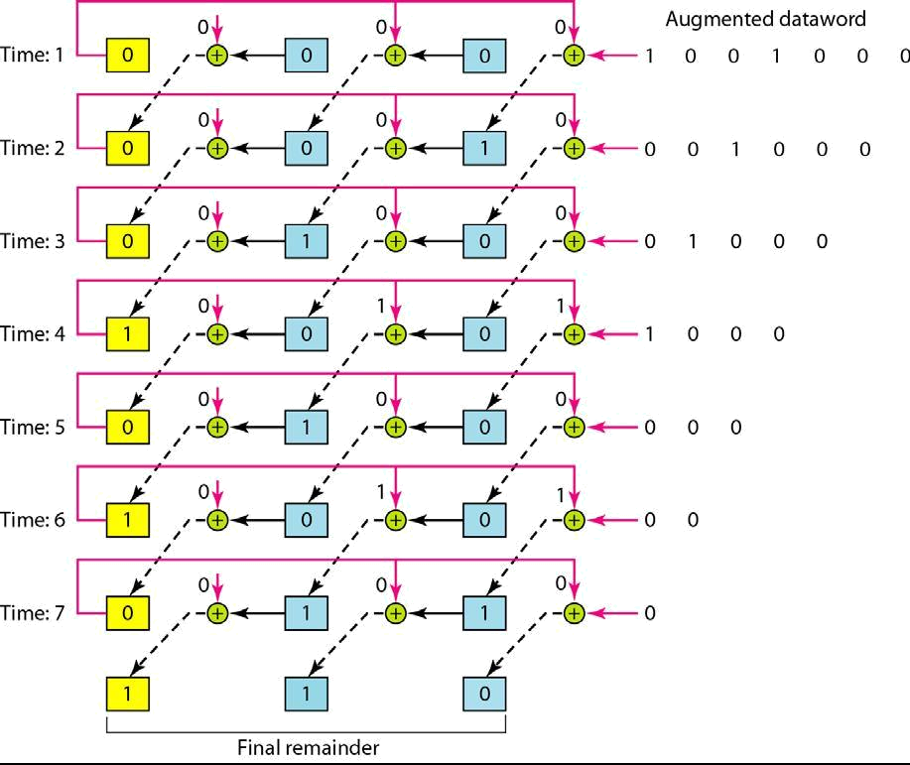

IMPLEMENTATION: (printout of codes)

d_bits=int(input("Enter number of data bits: "))
p_bits=2

#finding number of parity bits
while((d_bits+p_bits) > 2**p_bits):
p_bits+=1
bits=p_bits+d_bits
print("Number of parity bits required: ",p_bits)

#11-bit Hamming Code parity bit generator

d=input("Enter data bits: ")
d=[int(d[i:i+1]) for i in range(0, len(d))]
d.reverse()
#Finding parity positions
parityPos=[]
for i in range(0,p_bits):
parityPos.append(2**i)
print("Position of parity bits are: ",parityPos)

#Finding data bit position
finalArr=[i for i in range(1,12)]
dataPos=list(set(finalArr)-set(parityPos))
print("Position of data bits are: ", dataPos)

j=0
for i in dataPos:
finalArr[i-1]=d[j]
j+=1
#print("Intermediate stage: ")
#print(finalArr)
sum_dict={3:(1,2),5:(1,4),6:(2,4),7:(1,2,4),9:(1,8),10:(2,8),11:(1,2,8)}

#Finding corresponding positions for individual parity bits
XORList={}

for j in parityPos:
temp=list()
for k,v in sum_dict.items():
if j in v:
temp.append(k)
XORList[j]=temp

print(XORList)

for k,v in XORList.items():
temp=0
for pos in v:
temp^=finalArr[pos-1]
finalArr[k-1]=temp
finalArr.reverse()
print("Hamming code: ",''.join(str(x) for x in finalArr))

#Error Detection in Hamming Code

HammingData=input("Enter Hamming code: ")
HammingData=[int(HammingData[i:i+1]) for i in range(0, len(HammingData))]
HammingData.reverse()

parityCheck=[]
for k,v in XORList.items():
temp=0
temp^=HammingData[k-1]
for i in v:
temp^=HammingData[i-1]
parityCheck.append(temp)

parityCheck.reverse()
posi=0
for i in parityCheck:
posi= posi*10 +i
position=int(str(posi),2)
if(posi==0):
print("No error.")
else:
print("Error is at position(decimal): ", position)
print('Error is at position(binary): ',''.join(str(x) for x in parityCheck))
HammingData[position-1]+=1
HammingData[position-1]%=2
HammingData.reverse()
print("Corrected Hamming Code: ",''.join(str(x) for x in HammingData))

Output Screen:

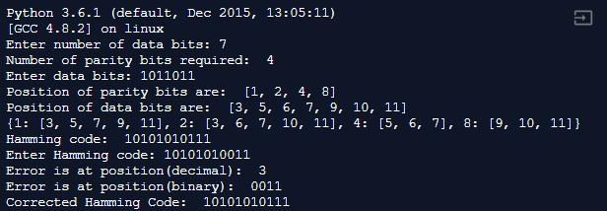

CONCLUSION:
The program for 11-bit hamming code was implemented successfully and the program ran without errors for all test cases.

Post Lab Questions

- State advantages of hamming code.

Ans.
The advantages of hamming code include:
- It is useful for a single bit change, which is more probable than two or more-bit changes.
- The simplicity of hamming codes makes them suitable for use in computer memory and single-error correction.
- Hamming codes can detect up to two-bit errors or correct one-bit errors without detection of uncorrected errors. By contrast, the simple parity code cannot correct errors, and can detect only an odd number of bits in error.
- They use a double-error detection variant called SECDED. These codes have a minimum hamming distance of three, where the code detects and corrects single errors while double bit errors are detected only if a correction is not attempted.
- It works well in low error rate applications telecoms.

Batch: B1 Roll No.: 1711072

Experiment / assignment / tutorial No. 3

Grade: AA / AB / BB / BC / CC / CD /DD

Signature of the Staff In-charge with date

Experiment No.: 3

TITLE: Implementation of CRC for Computer Networks
______________________________________________________________________
AIM: To implement Layer 2 Error Control schemes: Cyclic Redundancy Check.
______________________________________________________________________
Expected Outcome of Experiment:
CO: Describe Data Link Layer, MAC layer technologies &amp; protocols and implement the functionalities like error control, flow control.
__________________________________________________________________
Books/ Journals/ Websites referred:
- A. S. Tanenbaum, “Computer Networks”, Pearson Education, Fourth Edition
- B. A. Forouzan, “Data Communications and Networking”, TMH, Fourth Edition

____________________________________________________________________
Pre Lab/ Prior Concepts:
Data Link Layer, Error Correction/Detection, Types of Errors
___________________________________________________________________
New Concepts to be learned: CRC.
___________________________________________________________________

CRC:

- Consider 10011 as a data stream.

- Consider 101 as a generator polynomial.

- Add 00 at the end of the data stream. Data stream 1001100.
- Divide the data stream by 101.
- Append the remainder at the end of the data strea

- Send that data stream to the receiver.

- Repeat the same function at the receiver end side.

- If remainder 0 then data correct otherwise data incorrect.

IMPLEMENTATION: (printout of codes):

data=input("Enter the data to be sent: ")
gen=input('Enter the genf key: ')
red_code=str('0'*(len(gen)-1))
ap_data=data+str('0'*(len(gen)-1))
print("Appended Data is: ", ap_data)
def CRC(code,genf,redundant):
code=code+redundant
code,genf=list(code),list(genf)
for i in range(len(code)-len(redundant)):
if code[i]=='1':
for j in range(len(genf)):
code[i+j] = str(int(code[i+j])^int(genf[j]))
print(''.join(code))
return ''.join(code[-len(redundant):])
rem=CRC(data,gen,red_code)
res=data+rem
print('Remainder generated: ', rem,'\nData transmitted is: ',res)
rec=input("Enter the data received: ")
rec_data=CRC(rec[:-(len(gen)-1)], gen, rec[-len(gen)+1:])
print("Remainder on receiver side is: ",rec_data)

Output Screen:

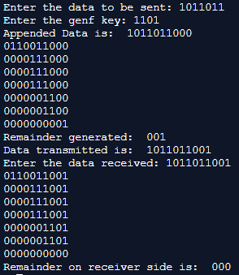

CONCLUSION:
The Python code for CRC Generator worked for both sender and receiver side successfully for all test cases.

Lab Questions
- In CRC there is no error if the remainder at the receiver is __.
A.equal to the remainder at the sender
B.zero
C.nonzero
D.the quotient at the sender
Ans. B. zero

- Let G(x) be the generator polynomial used for CRC checking. What is the condition that should be satisfied by G(x) to detect odd number of bits in error?

A. G(x) contains more than two terms
B. G(x) does not divide 1+x^k, for any k not exceeding the frame length
C. 1+x is a factor of G(x)
D. G(x) has an odd number of terms.

Ans. C. 1+x is a factor of G(x).

Batch: B1 Roll No.: 1711072

Experiment / assignment / tutorial No. 4

Grade: AA / AB / BB / BC / CC / CD /DD

Signature of the Staff In-charge with date

Experiment No.:4

TITLE: Implementation of Checksum for Computer Networks
______________________________________________________________________
AIM: To implement Layer 2 Error Control schemes: Checksum.
______________________________________________________________________
Expected Outcome of Experiment:
CO: Describe Data Link Layer, MAC layer technologies &amp; protocols and implement the functionalities like error control, flow control.
__________________________________________________________________
Books/ Journals/ Websites referred:
- A. S. Tanenbaum, “Computer Networks”, Pearson Education, Fourth Edition
- B. A. Forouzan, “Data Communications and Networking”, TMH, Fourth Edition

____________________________________________________________________
Pre Lab/ Prior Concepts:
Data Link Layer, Error Correction/Detection, Types of Errors
___________________________________________________________________
New Concepts to be learned: Checksum.
___________________________________________________________________

Checksum:
A checksum is a simple type of redundancy check that is used to detect errors in data.
Errors frequently occur in data when it is written to a disk, transmitted across a network or otherwise manipulated. The errors are typically very small, for example, a single incorrect bit, but even such small errors can greatly affect the quality of data, and even make it useless.
In its simplest form, a checksum is created by calculating the binary values in a packet or other block of data using some algorithm and storing the results with the data. When the data is retrieved from memory or received at the other end of a network, a new checksum is calculated and compared with the existing checksum. A non-match indicates an error; a match does not necessarily mean the absence of errors, but only that the simple algorithm was not able to detect any.
Simple Checksum:
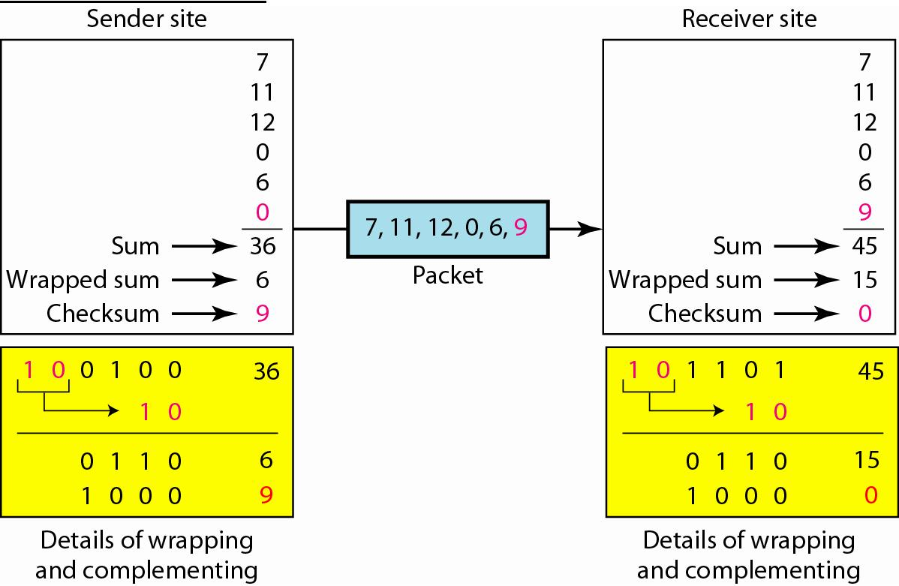

Internet Checksum
The following process generates Internet Checksum

Assume the packet header is: 01 00 F2 03 F4 F5 F6 F7 00 00
(00 00 is the checksum to be calculated)

The first step is to form 16-bit words.
0100 F203 F4F5 F6F7

The second step is to calculate the sum using 32-bits.
0100 + F203 + F4F5 + F6F7 = 0002 DEEF

The third step is to add the carries (0002) to the 16-bit sum.
DEEF + 002 = DEF1

The fourth step is to take the complement. (1s becomes 0s and 0s become 1s)
~DEF1 = 210E

So the checksum is 21 0E.

The packet header is sent as: 01 00 F2 03 F4 F5 F6 F7 21 0E

* At the receiver, the steps are repeated.

The first step is to form 16-bit words.
0100 F203 F4F5 F6F7 210E

The second step is to calculate the sum using 32-bits.
0100 + F203 + F4F5 + F6F7 + 210E = 0002 FFFD

The third step is to add the carries (0002) to the 16-bit sum.
FFFD + 0002 = FFFF which means that no error was detected.

(In 1s complement, zero is 0000 or FFFF.)

Example:
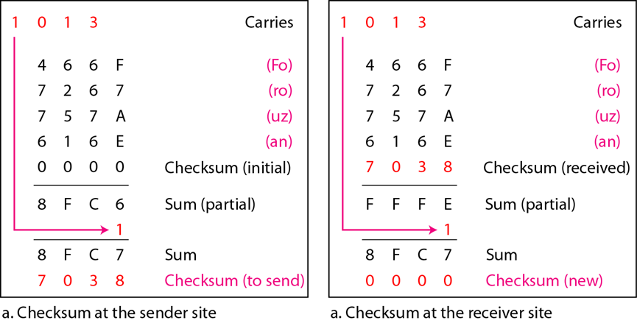

IMPLEMENTATION: (printout of codes)

d=input("Enter the data to send: ")
d=[(d[i:i+4]) for i in range(0, len(d),4)]
print('16 bit word format: ',','.join(str(x) for x in d))
def checksum(d):
data=[int(i,16) for i in d]
res=hex(sum(data))
print("Sum is: ",res)
res=res[2:]
wrap_sum=hex(int(res[0],16)+int(res[1:],16))
wrap_sum=wrap_sum[2:]
print('Wrapped sum: ',wrap_sum)
diff=hex(int('FFFF',16)-int(wrap_sum,16))
diff=diff[2:]
print('15\'s compliment: ',diff)
checksum(d)
r=input("Enter the data received: ")
r=[(r[i:i+4]) for i in range(0, len(r),4)]
checksum(r)

Output Screen:

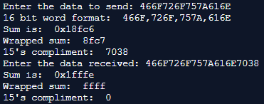

CONCLUSION:

The Python code for Checksum was implemented successfully as it ran correctly for all test cases.

Post Lab Questions

- State the advantages and disadvantages of Internet Checksum.

Ans.

Advantages:
- Checksum method is simpler than CRC method for error checking.
- A checksum is mainly employed in data validation when implementing software.
- Checksum method is simple to implement.

Disadvantages:
- Checksum is an old method for error checking.
- Due to its simple implementation, it can only detect single bit errors.
- It cannot be used for error correction in analogue data transmission.

Batch: Roll No.:

Experiment / assignment / tutorial No._______

Grade: AA / AB / BB / BC / CC / CD /DD

Signature of the Staff In-charge with date

Experiment No.:5

TITLE: Flow control Mechanism :Stop and Wait and Go-Back- N Sliding Window Protocol ARQ
___________________________________________________________________
AIM: Implementation of Flow Control Mechanism: Stop and Wait ARQ and Go-Back- N Sliding Window Protocol ARQ using sockets.

Expected Outcome of Experiment:
CO:

__________________________________________________________________
Books/ Journals/ Websites referred:
- A. S. Tanenbaum, “Computer Networks”, Pearson Education, Fourth Edition
- B. A. Forouzan, “Data Communications and Networking”, TMH, Fourth Edition
__________________________________________________________________
Pre Lab/ Prior Concepts:
Java Socket Programming, Flow Control, Go-Back-Stop and Wait
___________________________________________________________________
New Concepts to be learned: Window Flow Control ___________________________________________________________________

Design of Go-Back-N ARQ

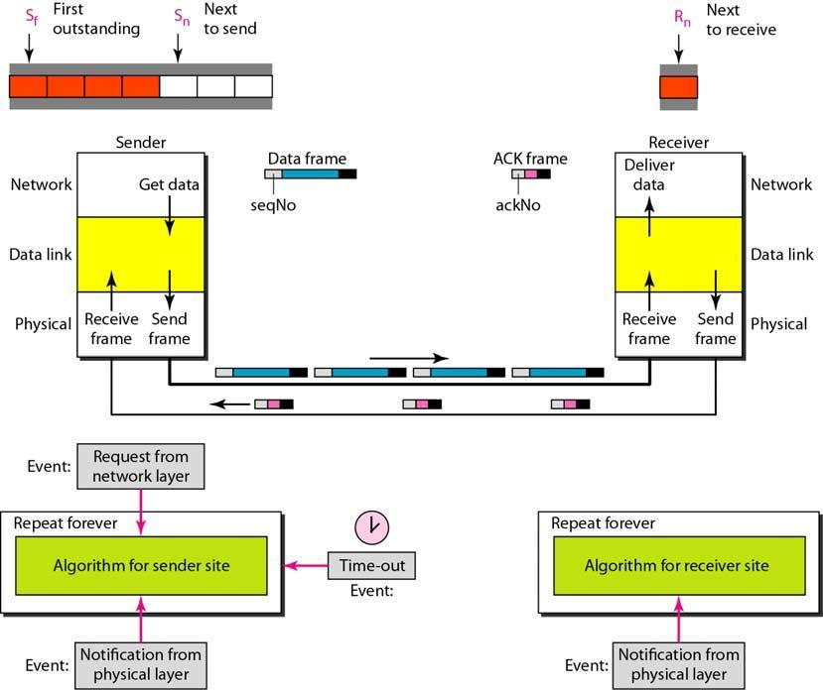

- Take data from user about how many bit windows is case of go back n and selective repeat.

- Generate frames randomly and show the transmission

- Generate the random number for the frame to be lost.

- For Go – Back – N transmit all the frames after that number till max number

- For Selective repeat transmit the selected frame which is not received by the receiver.

IMPLEMENTATION: (printout of code)

CONCLUSION:

Post Lab Questions

- Compare Go-Back-N and Stop and Wait.
- What is Flow Control and why it is necessary?
- The maximum window size for data transmission using the selective reject protocol with n-bit frame sequence numbers is
a) 2n b) 2n-1 c) 2n-1 d)2n-2

Batch: Roll No.:

Experiment / assignment / tutorial No._______

Grade: AA / AB / BB / BC / CC / CD /DD

Signature of the Staff In-charge with date

Experiment No.:6

TITLE: To Simulate a simple Network and analyse the packet flow between the nodes using NS-2.
______________________________________________________________________
AIM: To Simulate a simple Network and analyze the packet flow between the nodes using NS-2.
_____________________________________________________________________
Expected Outcome of Experiment:
CO:

_____________________________________________________________________
Books/ Journals/ Websites referred:
- A. S. Tanenbaum, “Computer Networks”, Pearson Education, Fourth Edition
- B. A. Forouzan, “Data Communications and Networking”, TMH, Fourth Edition
- http://www.isi.edu/nsnam/ns
____________________________________________________________________
Pre Lab/ Prior Concepts: Simple Network flow, Basic NS2 concepts
___________________________________________________________________
New Concepts to be learned: TCL language Node, Queue, Network Layout
____________________________________________________________________
Stepwise-Procedure:

NS-2 simulation involves following steps:

o Initialization & termination aspects of ns simulator

o Definition of network nodes, links, queues & topology o Definition of agents & of applications
o The NAM visualization tool
  - Tracing

Graphical plots using x-graph

- Initialization and termination

▪ Create simulator object:

set ns [new simulator]

▪ Open output files with data on the simulation (trace files) set tracefile1 [open out.tr w]

$ns trace-all $tracefile1

▪ Open a file for writing data for input to nam (network animator) set namfile [open out.nam w]

$ns namtrace-all $namfile

▪ Finish procedure :

proc finish {} {

global nstracefile1 namfile close $tracefile1
close $namfile

exec nam out.nam & exit 0

}

▪ Tell simulator object when to finish $ns at 5.0 “finish”

▪ Start the simulation $ns run

- Definition of network of links and nodes

▪ Creating nodes

set n0 [$ns node]
set n1 [$ns node]

▪ Creating link between nodes

$ns duplex-link $n0 $n1 1Mb 10ms DropTail

▪ Define buffer capacity of the queue related to each link 
       $ns queue-limit $n0 $n1 20

- Agents and applications

In ns the data is transferred between agents & not nodes, therefore we need to define

- routing (source,destinations)

- agents (protocols)

- Applications that use them
 

▪ Setup a TCP connection 
   set tcp [new agent/TCP]
$ns attach-agent $n0
$tcpset sink [new agent/TCPSink]
$ns attach-agent $n1 $sink $ns connect $tcp $sinkl

$tcp set fid_ 1

$tcp set packetSize_ 552 // by default 1000

▪ Setup a FTP over TCP connection 
  set ftp [new Application/FTP] $ftp attach-agent $tcp

▪ Telnet

set telnet [new Application/Telnet] $telnet attach-agent $tcp0

▪ Setup a UDP connection

set udp [new Agent/UDP]
$ns attach-agent $n0 $udp setnull [new Agent/Null]
$ns attach-agent $n1 $null
$ns connect $udp $null $udp set fid_ 2

▪ Setup a CBR over UDP connection

set cbr [new Application/Traffic/CBR]
$cbr attach-agent $udp

$cbr set packetSize_ 500 $cbr set interval_ 0.005 $cbr set random_ false

- Scheduling events

Start and stop of data $ns at <time> <event>

e.g. $ns at 0.1 “$cbr start”
$ns at 1.0 “$ftp start”
$ns at 15.0 “$ftp stop”
$ns at 20.0 “$cbr stop

- Visulisation using nam

▪ Give node position

$ns duplex-link-op $n0 $n2 orient right-down

▪ To obtain color

$ns color 1 Blue
 

▪ Other things

- Coloring nodes - $n0 color red

- Shape of nodes - $n1 shape box

(shape can be box/ hexagon/ circle, default is circle)

- Coloring links- $ns duplex-link-op $n0 $n2 color “green”

- Adding and removing marks

$ns at 2.0 “$n3 add-mark m3 blue box” $ns at 30.0 “$n3 delete-mark m3”

5. | Adding labels
 | At node - | $ns at 1.2 “$n3 label | \ “ active node\” ”
 | To link – | $ns duplex-link-op $n0 | $n2 label “TCP input link “
6. | Adding text:(Annotation)
 |  | $ns at 5 “$ns trace-annotate \”packet drop\” “
7.Monitoring queue size

$ns simplex-link-op $n2 $n3 queuePos 0.5

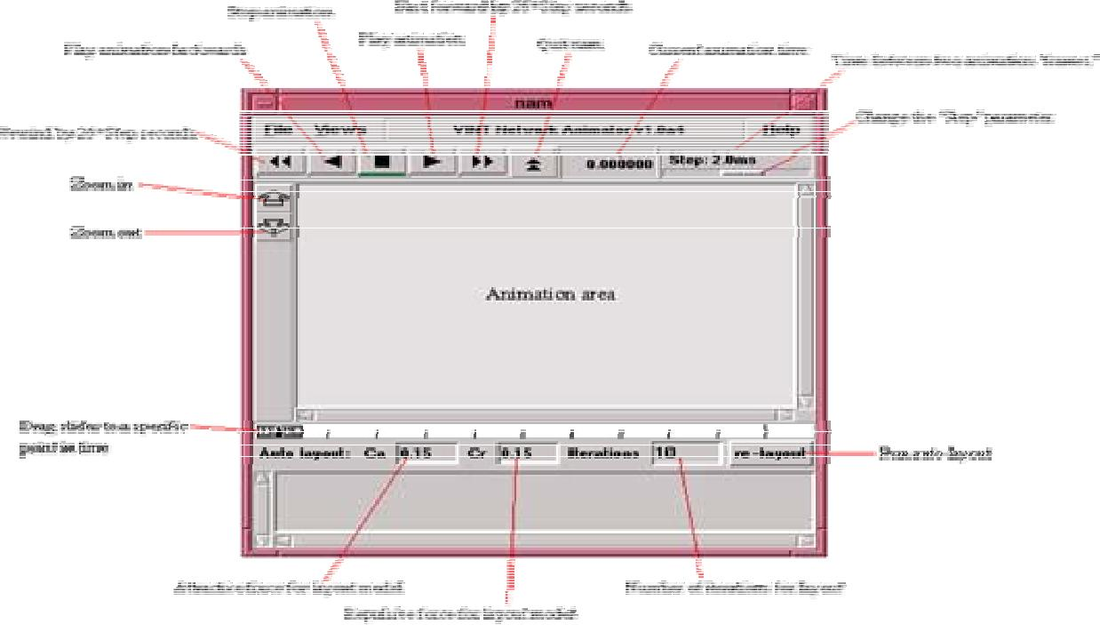

- Tracing

Tracing into an o/p ASCII file is organized into 12 fields as shown-

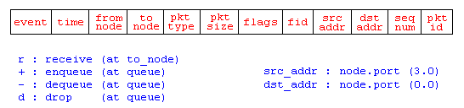

Fig above shows the Trace file format with the following fields

1.event: Event _Type: r, +, -, d : receive , enqueued ,dequeued & dropped packets

- time: time at which event occurs

- from node: i/p node of link at which event occurs
- to node: o/p node of link at which event occurs

- pkt type: cbr or tcp (depending upon application)

- pkt size: size in bytes

- flags: some flags
- fid: Flow ID of IPv6, Used to specify stream color for nam display
- src addr: Source address in “node.port” form

10.dst addr: destination address in the same format
11.seq num: N/w layer protocol’s sequence number
12.Pkt id: unique id of packet

IMPLEMENTATION: (printout of code)

CONCLUSION:

Post Lab Questions
- What is use of NS2?
- State different features of NS2.
- List different network simulators?

Batch: Roll No.:

Experiment / assignment / tutorial No._______

Grade: AA / AB / BB / BC / CC / CD /DD

Signature of the Staff In-charge with date

Experiment No.:7

TITLE: Building of simple topology using Network tool (CISCO PACKET TRACER).

______________________________________________________________________
AIM: To build a simple network topology using CISCO Packet Tracer.

Packet Tracer is a network simulation program that allows students to experiment with network behaviour and ask “what if” questions. Packet Tracer provides simulation, visualization, and authoring, assessment, and collaboration capabilities and facilitates the teaching and learning of complex technology concepts.
____________________________________________________________________
Expected Outcome of Experiment:
CO:

_______________________________________________________________
Books/ Journals/ Websites referred:
- A. S. Tanenbaum, “Computer Networks”, Pearson Education, Fourth Edition
- B. A. Forouzan, “Data Communications and Networking”, TMH, Fourth Edition
- CISCO PACKET TRACER 6.0.1 (free download)
_____________________________________________________________________
Pre Lab/ Prior Concepts: Simple Network flow
____________________________________________________________________
New Concepts to be learned: Purpose of this lab is to become familiar with building topologies in Packet Tracer.
___________________________________________________________________
Stepwise-Procedure:

Creating a simple LAN network using packet tracer:
Step 1: Select two PCs (PC0 and PC1) from the end devices and one fast ethernet switch (2950/24 ports)

Step 2: Connect PCs and switch via copper cable from the panel. Connection can be verified by appearance of all green dots on the links.

Step 3: For PCs to communicate click on PC0.
- Dialog box for PCO appears
- Click on desktop applications by packet tracer.
- Go to IP configuration.
- Enter IP address to identify host i.e. PC0 (for example: 192.168.1.1)
- Subnet mask-by default already set one can change it as per his/her specification.

Step 4: Repeat step 3 for PC1

Step 5: Ping both the check their working status.

Step 6: Simple PDU (Protocol Data Unit) to simulate network traffic by sending ICMP PDU to assess the network traffic. View simulation in simulation mode

IMPLEMENTATION: (printout of simulation code)

CONCLUSION:

Post Lab Questions

- List features of CISCO packet tracer.

Batch: Roll No.:

Experiment / assignment / tutorial No._______

Grade: AA / AB / BB / BC / CC / CD /DD

Signature of the Staff In-charge with date

Experiment No.:8

TITLE: To study and observe various data formats.
______________________________________________________________________
AIM: : To analyse and interpret the various data formats used as signals in digital communication.
____________________________________________________________________
Expected Outcome of Experiment:
CO:

_________________________________________________________________
Books/ Journals/ Websites referred:
- George Kennedy “Electronic Communication System” 4nd Edition, Tata McGraw-Hill Education, 01-Jun-1999.
- Taub Schilling, “Principles of Communication Systems”, 3rd Edition, McGraw-Hill Publications.
____________________________________________________________________
Pre Lab/ Prior Concepts: Data formats are used as signals for digital communication systems. Different types of data formats are NRZ,RZ , Bi-phase Manchester, Bipolar RZ etc.

fs ≥ 2 fm
____________________________________________________________________________
New Concepts to be learned: Concepts of digital transmission

APPARATUS: Trainer kit, connecting wires, CRO.
THEORY: Write about NRZ(M), Clock Recovery , Bandwidth and DC level, Decoding, Return to Zero (RZ) format, Receiver Clock, Biphase(Manchester) coding, Problem in decoding .
PROCEDURE: 1) This experiment makes use of two trainers namely data conditioning and carrier modulation transmitter trainer, and data reconditioning and carrier demodulation receiver trainer.
2) Ensure all trainers are switched OFF until complete connections rea made.
3) Set trainer mode switch in position 2
4) Switch On the power supply.
5) Observe the DATA CLOCK O/P on the trainers DATA FORMAT block with CRO. Adjust the CRO tune base and position control until each rising edge of data coincides with one slopes vertical graticule line, each main division on CRO horizontal axis now represents on data bit line.Adjust the trigger level.
6) Monitor NRZ(M), RZ, Biphase, Manchester, Biphase(Mark) O/P in DATA FORMATING
7) Switch OFF the instrument and make connections.
8) Connect O/P to bit decoderI/P.
9) Connect the clock signal to clock I/P terminal.
10) Switch ON the power and observe waveforms on CRO.

CONCLUSION:

Post Lab Descriptive Questions (Add questions from examination point view)

- Draw data following data formats for the given sequence 101110
- NRZ
- RZ
- Manchester

Batch: Roll No.:

Experiment / assignment / tutorial No._______

Grade: AA / AB / BB / BC / CC / CD /DD

Signature of the Staff In-charge with date

Experiment No.:9

TITLE To study TDM Pulse Amplitude Modulation and Demodulation.
______________________________________________________________________
AIM: To understand the TDM system
____________________________________________________________________
Expected Outcome of Experiment:
CO:

_________________________________________________________________
Books/ Journals/ Websites referred:
- George Kennedy “Electronic Communication System” 4nd Edition, Tata McGraw-Hill Education, 01-Jun-1999.
- Taub Schilling, “Principles of Communication Systems”, 3rd Edition, McGraw-Hill Publications.
____________________________________________________________________
Pre Lab/ Prior Concepts: Time-division multiplexing (TDM) is a type of digital (or rarely analog) multiplexing in which two or more bit streams or signals are transferred appearing simultaneously as sub-channels in one communication channel, but are physically taking turns on the channel. The time domain is divided into several recurrent time slots of fixed length, one for each sub-channel. A sample byte or data block of sub-channel 1 is transmitted during time slot 1, sub-channel 2 during time slot 2, etc. One TDM frame consists of one time slot per sub-channel plus a synchronization channel and sometimes error correction channel before the synchronization. After the last sub-channel, error correction, and synchronization, the cycle starts all over again with a new frame, starting with the second sample, byte or data block from sub-channel 1, etc.
______________________________________________________________________
New Concepts to be learned: Concepts of digital transmission

APPARATUS: Trainer kit, connecting wires, CRO.
THEORY: Write about Time Division Multiplexing and explain its applications, advantages and disadvantages.

PROCEDURE: 1) Connect jumper TDM O/P from multiplexer section to TDM I/P of de multiplexer section.
- Connect signal I/P 1 terminal of mux section to sine wave signal of sine wave generator with frequency amplitude of 2Vp-p.
- Connect signal I/P 2 terminal of mux section to sine wave signal of sine wave generator with frequency amplitude of 1Vp-p.
- Connect signal I/P 3 terminal of mux section to sine wave signal of sine wave generator with frequency amplitude of 2Vp-p.
- Connect signal I/P 4 terminal of mux section to sine wave signal of sine wave generator with frequency amplitude of 0.5Vp-p.
- Connect CRO ch-1 at TDM O/P signal. Observe TDM signal.
- Connect ch-2 at the demux O/P 1 of demodulator section. Observe recovered sin wave Signal 1
- Connect ch-2 at the demux O/P 2 of demodulator section. Observe recovered sin wave Signal 2
- Connect ch-2 at the demux O/P 3 of demodulator section. Observe recovered sin wave Signal 3
- Connect ch-2 at the demux O/P 4 of demodulator section. Observe recovered sinwave Signal 4

CIRCUIT DIAGRAM OR BLOCK DIAGRAM: TDM Pulse Amplitude Modulation/ Demodulation
TDM
LPF
3.4KHZ
LPF
3.4KHZ

LPF
3.4KHZ

LPF
3.4KHZ
F

Sampling SIGNAL

Sampling Pulse Generator
SPG

CONCLUSION:

Post Lab Descriptive Questions
- Explain application of TDM.

Batch: Roll No.:

Experiment / assignment / tutorial No._______

Grade: AA / AB / BB / BC / CC / CD /DD

Signature of the Staff In-charge with date

Experiment No.:10

TITLE To study BASK , BFSK and BPSK modulation techniques.
______________________________________________________________________
AIM: To understand the BASK , BFSK and BPSK techniques.
____________________________________________________________________
Expected Outcome of Experiment:
CO:

_________________________________________________________________
Books/ Journals/ Websites referred:
- George Kennedy “Electronic Communication System” 4nd Edition, Tata McGraw-Hill Education, 01-Jun-1999.
- Taub Schilling, “Principles of Communication Systems”, 3rd Edition, McGraw-Hill Publications.
____________________________________________________________________
Pre Lab/ Prior Concepts: Amplitude shift keying - ASK - in the context of digital communications is a modulation process, which imparts to a sinusoid two or more discrete amplitude levels. These are related to the number of levels adopted by the digital message.
A binary amplitude-shift keying (BASK) signal can be defined by
s(t) = A m(t) cos 2πfc , 0 < t < T
where A is a constant, m(t) = 1 or 0, fc is the carrier frequency, and T is the bit duration. It has a power P = A2/2, so that A = 2P.
In phase shift keying (PSK), the phase of a carrier is changed according to the modulating waveform which is a digital signal. InBPSK, the transmitted signal is a sinusoid of fixed amplitude. It has one fixed phase when the data is at one level and when thedata is at the other level, phase is different by 180 degree. A Binary Phase Shift Keying(BPSK) signal can be defined as

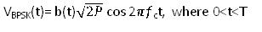
where b(t) = +1 or -1, fc is the carrier frequency, and T is the bit duration. The signal has a power , so that , where A represents the peak value of sinusoidal carrier.

Frequency-shift keying (FSK) is a frequency modulation scheme in which digital information is transmitted through discrete frequency changes of a carrier wave. Frequency Shift Keying (FSK) modulation is the process of modulating a digital signal onto a carrier that is composed of one of two frequencies, one frequency for high - and the other frequency for low.
FSK demodulation is the process of recovering the original signal by detecting the frequencies involved in the original modulation. Typically, this is done with a bandpass amplifier tuned to one of the two frequencies, followed by a amplitude demodulator. The output is the original signal. It is possible, though often unnecessary; to use two bandpass amplifiers, one for each frequency, but this is redundant. It is also possible to use a digital signal processing technique to perform a fourier transform on the input signal, but that can be complex and costly.

APPARATUS: Trainer kit, connecting wires, CRO.

THEORY: Write about ASK , FSK and PSK Modulation and Demodulation.

PROCEDURE: (BASK)
  - Ensure all the trainers are switched OFF until the complete connections are made.
  - Set the trainer mode to switch in position 2
  - Observe the DATA CLOCK output on trainers DATA FORMAT block with CRO. Adjust CRO accordingly.
  - Make additional connections:
- NRZ (L) O/P to carrier modulation signal.
- 1.44MHZ carrier O/P to carrier I/P.
- Connect modulator O/P to ASK input.
- LPF1 O/P to comparator 1 I/P
- ASK demodulator O/P to LPF 1
  - Turn ON the trainer and the monitor NRZ(L) O/P from trainer on one channel of CRO use other channel to monitor O/P of modulator1.
  - 3 Variables have been provided:
- Gain: Adjusts amplification of Mod 1
- Modulation offset: Used to adjust the amplitude of signal.
- Carrier Offset: Adjust OFF bias level. Adjust till OFF level.
  - To see the Demodulating process observe the O/P at the ASK demodulator and LPF
PROCEDURE: (BPSK) As a continuation from the previous experiment.
  - Ensure all the trainers are switched OFF until the complete connections are made.
  - Set the trainer mode to switch in position 2
  - Switch ON the Power.
  - Observe the DATA CLOCK O/P on the trainers DATA FORMAT block with CRO. Adjust the CRO tune base and position control until each rising edge of data coincides with one slopes vertical graticule line, each main division on CRO horizontal axis now represents on data bit line.
  - Set S/W in PSK demodulator block to 960KHZ position.
  - Switch OFF the power and make additional connections:
- Carrier I/P to mod1
- NRZ (M) O/P to unipolar converters I/P.
- Unipolar bipolar converters O/P to mod1 I/P
  - Connect mod1 O/P to PSK demodulator I/P
ON 7575 trainer
- PSK demod O/P to LPF1.
- LPF1 O/P to comparator 1 I/P.
- Comparator 1 O/P to bit decoder I/P.
  - Switch on the trainers
  - Monitor the O/P of mod1 with reference to its I/P by using a dual trace CRO. The three controls in modulator block may require some setting:
- Gain: Controls amplitude of mod O/P signal
- Modulation Offset : Controls p-p amplitude of 0 degrees and 180 degree phase relative to each other vary till amplitude of both the phases become equal.
- Carrier Offset: Controls DC offset of two phases namely 0 degree and 180 degree phase relative to each till DC offset is reduced to 0V. Display NRZ(M) I/P with PSK modulated waveform helps to understand the PSK modulation concept . Notice that NRZ(M) waveform level changes, PSK modulated waveform undergoes a 180 degree phase change.
  - To see the PSK demodulation process examine the I/P of PSK demodulator trainer with demodulator O/P, adjust the Phase adjust control and see its effect on demodulation O/P.
  - The O/P of Demodulator goes to LPFs I/P monitor the filter O/P with reference to it’s I/P.
  - LPFs O/P is rounded off and cannot be used for digital processing in order to square up the waveform Comparators are used.
  - The carrier frequency used is 960KHZ, 1.44 MHZ carriers can also be used. The only change to be made is to put PSK demodulator S/W in 1.44MHZ position.
PROCEDURE: (BFSK)
- Ensure that all trainers are switched OFF until the complete connection is made.
- Set the trainer mode switch in position 2.
- Make connection as shown in fig.
- Switch “ON” the power.
- Observe the DATA CLOCK output on trainers DATA FORMAT block with oscilloscope. Adjust the oscilloscope tune base and position control until each rising edge of data clock coincides with one slope vertical graticule line as shown in fig., each main division on scopes horizontal axis new represent on data bit time.
- Switch OFF the power, make additional connections as shown in fig.:
On Adtron’s 7514 trainer:
- NRZ(L) o/p to modulation i/p of unipolar bipolar converters.
- Modulation i/p to data inverter i/p.
- Modulation o/p to summing amplifier i/p.
- Data inverter o/p to modulation i/p of modulator 2.
- 1.44 MHz carrier to modulator 1 carrier i/p.
- 960 KHz carrier to modulator 2 carrier i/p.
- Modulator 2 o/p to summing amplifier i/p.
- ASK Demodulator o/p to LPF1 i/p.
- LPF1 o/p to comparator 1 i/p.
On Adtron’s 7515 trainer:
- PLL detectors o/p to LPF1 i/p.
- LPF 1 o/p to Comparator 1 i/p.

- Monitor the o/p of modulator 1 and make adjustments of:
- Gain: Adjust this pot until amplitude of th ‘0’ signal is 2v p-p.
- Modulation offset: It is used to adjust the amplitude of OFF signal, adjust it till the OFF signal level doesn’t approach as close to zero as possible.
- Carrier offset: This control adjusts the off bias level of ASK waveform. Adjust till the off level occurs midway between the peaks of the ON signal level of the signal.

- Repeat step no. 6 with modulator 2 by observing its o/p.
- Observe the o/p of the summing amplifier. Adjust the gain control of modulator 2 if necessary to make the amplitude of the frequency components equal.
- Display the FSK waveform simultaneously with NRZ(L) o/p, observe that for data bit ‘0’ the FSK signal is at lower frequency(960 KHz) for data bit ‘1’ the FSK signal is at higher frequency(1.44 MHz)
- Now to study about demodulation examines the i/p and o/p of trainer kit FSK Demodulator. Observe that the o/p voltage of the PLL detector is greater for higher incoming frequency, also observe that for both incoming carrier frequencies, the demodulators o/p also contains a component at that frequency.
- Observe the i/p and o/p LPF 1 simultaneously. This o/p contains no carrier frequency components.
- The rounded o/p of LPF is removed by passing it through the data squaring circuits. But prior to it the BIAS level of the comparators 1 is to be adjusted to a value until the o/p pulse width is same as the NRZ(L) i/p, for this purpose display them simultaneously. Observe that the comparators o/p is slightly delayed then NRZ(L) i/p.

CONCLUSION:

Post Lab Descriptive Questions
- State applications of BFSK , BASK and BPSK
- List advantages and disadvantages of BFSK , BASK and BPSK

